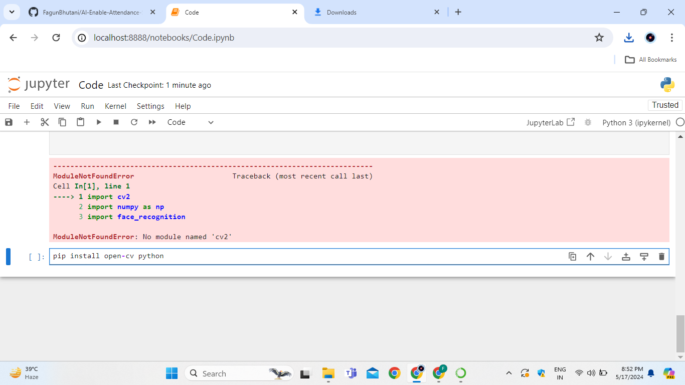Libraries required to download are-

1.Opencv-python

2.Face_Recognition

Now if you face error in this library you may refer to this video:-

<https://youtu.be/LAeACJdv40U>

Step1-Try to pip install face_recognition

Step2-If you got an error of cmake and unable to build dlib wheel.

Step3-Then pip install cmake

Step4-Now download library from the github link according to your version and then copy the file to desktop folder(make a new folder) then copy path.

Step5-The pip install(file path) and change slashes.

3.Pillow

Step1-pip install pillow